Project Title | Mahagi One Stop Border Post (OSBP) Infrastructure Upgrade
Project Leads | Government of the Democratic Republic of Congo (Ministry of External Trade, Directorate of Immigration and Excise, Directorate General of Customs and Excise, Ituri Province), and TradeMark Africa (TMA)
Funding | UK, Finland, Netherlands
Implementation Period | 2019–2026
Project Partners | DRC’s Ministry of External Trade, Northern Corridor Transit and Transport Coordination Authority, Direction Generale des Douanes et Accises, the DRC Customs, DRC Immigration, Office Congolais de Controle, OCC (The standard Service), Programe de l'hygiene aux Frontieres, PNHF (Health Service), Ituri Provincial Government
Project Participants | Cross border traders
Project Rationale | Mahagi border, which connects the DRC to Uganda at Goli on the Northern Corridor, is a strategic trade gateway between Eastern and Central Africa. Yet for years its potential has been undermined by fragmented border procedures, repeated inspections, outdated infrastructure and weak ICT connectivity. The result has been crossing delays of up to eight hours for traders and transporters.  These inefficiencies imposed direct economic costs. They have raised transport and logistics expenses, increased uncertainty in supply chains, heightened the risk of spoilage for perishable goods, and eroded profit margins. The effects have been felt most sharply by the thousands of small-scale traders who depend on the crossing every day for income and market access.
Implementation Strategy | TMA’s implementation approach is deliberately integrated. It combines hard infrastructure, systems reform and trader support so that Mahagi becomes a more efficient crossing.  - Physical Infrastructure (OSBP's) and Connectivity to create resilient facilities for a functioning One Stop Border Post  - Border Facilities: Construction of modern administration blocks, specialised warehouses, and secure, paved truck parking areas.  - Engineering & Durability: Installation of retaining walls to ensure site stability and the rehabilitation of the Nyibola River bridge to secure and reliable regional connectivity.  - Essential Utilities: Deployment of comprehensive site services, including CCTV surveillance, perimeter fencing, public lighting, and industrial-grade water and sanitation facilities.  - Systems Modernisation and Operational Harmonisation: To eliminate administrative fragmentation, the project digitises workflows and aligns bilateral protocols:  - Digital Integration: Deployment of ICT systems to facilitate real-time data exchange between DRC and Uganda customs authorities, streamlining the clearance process.  - Unified Protocols: Development of Joint Standard Operating Procedures (SOPs) and specialized training for border staff in integrated control and performance monitoring.  - Process Optimisation: Transitioning to a single-stop logic to eliminate repeated stops and redundant inspections.  - Inclusive Trade and Stakeholder Support  The strategy ensures that modernisation benefits the most vulnerable economic actors through targeted social investments:  - Cross-Border Market: Development of a modern market facility designed to transition informal and small-scale traders into formal trade systems.  - Targeted Empowerment: Implementation of capacity-building and outreach programs specifically for women traders and vulnerable groups, ensuring equitable access to the new infrastructure.  - Safety & Access: Creating a secure environment that encourages the participation of small-scale entrepreneurs in regional value chains.
Progress | - Phase I - funded by: Netherlands, UK International Development- completed November 2023: Paved parking area, constructed warehouse and gatehouse, installed fencing, deployed CCTV.  - Phase II - funded by: Finland – completed in November 2024: Built administration block, drilled water facilities, constructed retaining wall, installed lighting, and improved water and sanitation systems.  - Phase III - funded by: UK International Development, ongoing and target completion 2026): Upgrading access roads, rehabilitating the Nyibola River bridge, constructing cross-border market and staff housing, rolling out digital customs systems.
Emerging Results Results | - Time taken from queuing to clearance in Goli reduce by over half, from over 17 hours in 2019 to under eight in 2024.  - 63% reduction in customs processing time at Goli-Mahagi OSBP from eight hours in 2019 to three in 2024  - The Goli-Mahagi OSBP recorded more than a 100% rise in total trade volumes, from nearly $18 million in 2019 to about $41 million in 2022, driven by the introduction of trade facilitation measures like the Integrated Border Management (IBM) system.  Source of data: Physical Infra S2 Evaluation Final Report 16 04 25.pdf
Photo – Phase II of Mahagi – see cream administration block at the background and paved parking front and middle. | 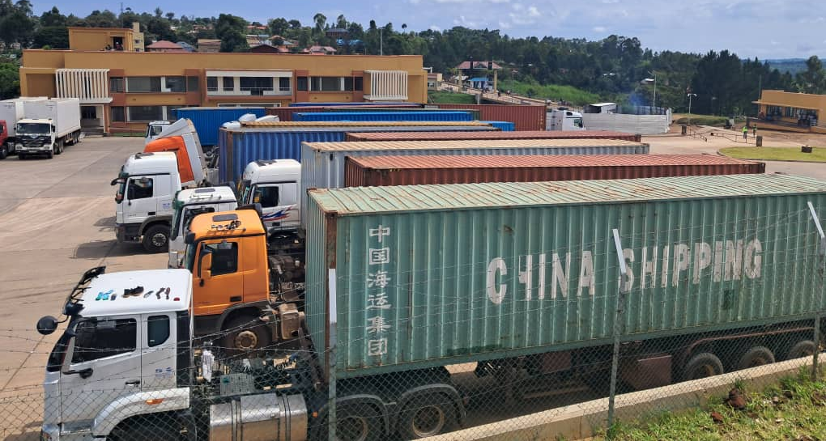
Contact | Aimé Nzoyihera– County Director, DRC  Email : aime.nzoyihera@trademarkafrica.com

